Introducing column addition lesson plan

DAY | We Are Learning To (WALT): | MODEL / INTRODUCTION | INDEPENDENT WORK | PLENARY
 | Mental:  Main:  Use column addition (with partitioning) | Mental:  Main:  TA to take children who are unable to add a 1-digit number to a 2-digit number (e.g. 47 + 8) and / or are unable to add multiples of 10 (e.g. 40 + 20)  Practice counting up to 100, especially focusing on crossing tens barriers  Practice counting up to 100 in tens  Calculate mentally by putting first number in head and counting on, using fingers to keep count  Work on setting these questions out in columns and calculating them mentally  Go through PowerPoint with the following:  - Explanation of the difference between horizontal / vertical and what a column is  - Example of how we will be setting out our work in 2 different ways for each question today (with partitioning and without partitioning – this reinforces the idea that without partitioning a 1 in the tens column is a ten, not just a unit):  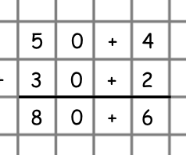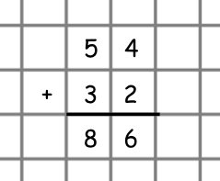  With every example on following slides reinforce four main teaching points:  - Start on the right-hand side  - Put only 1 number in a square  - Write the +  - Put units under units and tens under tens and so on  - Examples of adding covering differentiation below  (After doing the example before the decimals, have middle and higher ability go and stick success criteria in their books)  - Final slide with reminders of the 4 key points above (success criteria)  Remind children to leave space between calculations and not squash them together  Have a copy of the success criteria to stick at the top of their page on each child’s desk (except for lower ability as they do not need to think about all of the criteria) | (At regular intervals have children stop and check their work against the success criteria)  Lower ability – add 1-digit numbers and multiples of 10 (give unit squares and tens sticks if really needed)  Middle ability – add 2-digit numbers (no carrying)  Higher ability – add 3-digit numbers (no carrying)  Extension – add 4-digit numbers and numbers to 1 decimal place (no carrying) | Have children self-asses their work against the success criteria  In ability partners give children 1 question to do each  Children need to talk to their partner, explaining what they are doing e.g. I will put the 3 under the 5 because they are both units. Then I will put the 40 under the 20 because they are both tens. Then I draw my equals line with a ruler. Then I start on the right and add the digits first and then add the tens  Children swap over and partner who spoke first now listens

© www.SaveTeachersSundays.com 2013

